Djelo: Mama je kriva za sve

Pisac: Zoran Pongrašić

VRSTA: PRIPOVIJETKA BAJKA DJEČJI ROMAN IGROKAZ
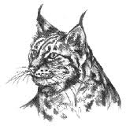
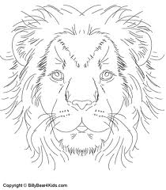
TEMA: _______________________________________________________________________________
MJESTA RADNJE: ______________________________________________________________________
VRIJEME RADNJE: __________________________________________
Glavni lik:
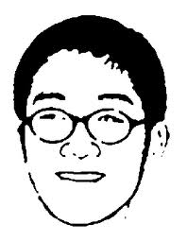
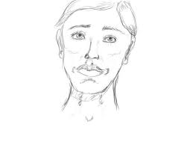
BE ____________________________________
Osobine: _________________________________________________________________________________
Ostali likovi: _____________________________________________________________________________
_____________________________________________________________________________
Nacrtaj po čemu su lopovi dobili nadimke.

__________________ ______________________
Prepiši opis blizanki: ________________________________________________________________________
__________________________________________________________________________________
__________________________________________________________________________________
__________________________________________________________________________________
U osmosmjerci pronađi i oboji likove: BAKA, MIRELA, STELA, BRANKA, ARČI, OŽILJAK, KRANJEC, BRADA, EUGEN i FRANJO.
Ostala slova su likovi: _______________________________ i
_____________________________________.
Ukratko opiši najsmješniji događaj.
__________________________________________________________________________________
__________________________________________________________________________________
__________________________________________________________________________________
__________________________________________________________________________________
A | K | A | B | S | P | O | K
I | Č | R | A | T | B | Ž | R
O | L | F | I | E | R | I | A
M | I | R | E | L | A | LJ | NJ
C | A | A | U | A | D | A | E
J | A | NJ | G | C | A | K | C
 | M | O | E | I | L | I | C
B | R | A | N | K | A | A
__________________________________________________________________________________

__________________________________________________________________________________
__________________________________________________________________________________
__________________________________________________________________________________

